Assignment 1 - Artificial Intelligence

Complete Solutions with Diagrams

# Q.1 Define the following terms:

**Intelligence:** Intelligence refers to the ability to acquire knowledge, learn from experience, understand complex concepts, adapt to new situations, and apply reasoning to solve problems effectively.

**Logical Reasoning:** Logical reasoning is the process of using structured, rule-based thinking to draw conclusions from premises. It involves applying principles of logic (deductive, inductive, abductive) to analyze information and make sound inferences.

**Agents:** In AI, an agent is an autonomous entity that perceives its environment through sensors and acts upon it through actuators to achieve specific goals. Agents can be software programs, robots, or any system that can perceive and act.

**State and Path:** State represents a particular configuration or situation in a problem space at any given time. Path is the sequence of actions that connects the initial state to the goal state, representing the solution route through the problem space.

**State Space:** State space is the set of all possible states that can be reached from the initial state by applying a sequence of valid actions. It represents the complete problem domain that a search algorithm explores.

**Fuzzy Logic:** Fuzzy logic is a form of many-valued logic that deals with approximate reasoning rather than precise true/false values. It allows variables to have degrees of truth between 0 and 1, enabling better handling of uncertainty and imprecision.

**Decision Making:** Decision making in AI refers to the process by which an intelligent system chooses the best course of action from available alternatives based on available information, goals, and constraints.

**Membership Function:** A membership function in fuzzy logic quantifies the degree to which an element belongs to a fuzzy set. It maps input values to membership values between 0 and 1, where 0 means no membership and 1 means full membership.

# Q.2 Define AI and explain why and where to use AI

Artificial Intelligence (AI) is the capability of computational systems to perform tasks typically associated with human intelligence, such as learning, reasoning, problem-solving, perception, and decision-making.  
  
Why Use AI:  
• Efficiency: AI can process vast amounts of data faster than humans  
• Consistency: AI systems provide consistent results without fatigue  
• Automation: Can handle repetitive tasks, freeing humans for complex work   
• Pattern Recognition: Excellent at identifying patterns in large datasets  
• 24/7 Availability: Can operate continuously without breaks  
  
Where to Use AI:  
• Healthcare: Medical diagnosis, drug discovery, patient monitoring  
• Finance: Fraud detection, algorithmic trading, risk assessment  
• Transportation: Autonomous vehicles, route optimization  
• Manufacturing: Quality control, predictive maintenance  
• Education: Personalized learning, intelligent tutoring systems  
• Entertainment: Recommendation systems, content creation

# Q.3 Define Intelligence and Explain its types

Intelligence is the ability to acquire knowledge, learn from experience, understand complex concepts, adapt to new situations, solve problems, and apply reasoning effectively.  
  
Types of Intelligence in AI:  
  
1. Artificial Narrow Intelligence (ANI/Weak AI):  
 • Designed for specific tasks only  
 • Cannot perform beyond programmed capabilities  
 • Examples: Siri, facial recognition, chess programs  
  
2. Artificial General Intelligence (AGI/Strong AI):  
 • Theoretical concept with human-level cognitive abilities  
 • Can understand, learn, and apply knowledge across multiple domains  
 • Currently does not exist  
  
3. Artificial Superintelligence (ASI):  
 • Hypothetical AI that exceeds human intelligence in all areas  
 • Would surpass humans in creativity, general wisdom, and problem-solving  
 • Purely theoretical concept

# Q.4 Define Intelligent System and Explain its types

An Intelligent System is a computational system that can perceive its environment, process information, learn from experience, and make decisions to achieve specific goals autonomously.  
  
Types of Intelligent Systems:  
  
1. Knowledge-Based Systems:  
 • Use domain-specific knowledge to solve problems  
 • Examples: Expert systems, diagnostic systems  
  
2. Machine Learning Systems:  
 • Learn patterns from data to make predictions  
 • Types: Supervised, Unsupervised, Reinforcement Learning  
  
3. Neural Network Systems:  
 • Mimic human brain structure and function  
 • Examples: Deep learning networks, convolutional neural networks  
  
4. Fuzzy Logic Systems:  
 • Handle uncertainty and imprecise information  
 • Use fuzzy sets and approximate reasoning  
  
5. Evolutionary Systems:  
 • Use evolutionary algorithms for optimization  
 • Examples: Genetic algorithms, genetic programming

# Q.5 What is an agent and its environment? Explain types of agents in AI

Agent: An agent is an autonomous entity that perceives its environment through sensors and acts upon it through actuators to achieve specific goals.  
  
Environment: The environment is everything outside the agent that the agent can perceive and act upon. It provides the context in which the agent operates.  
  
PEAS Framework:  
• Performance: Measures how well the agent achieves its goals  
• Environment: The external world the agent operates in  
• Actuators: Components that allow the agent to act  
• Sensors: Components that allow the agent to perceive  
  
Types of Agents:  
  
1. Simple Reflex Agents:  
 • React based on current perceptions only  
 • Use condition-action rules (if-then)  
 • No memory of past states  
  
2. Model-Based Reflex Agents:  
 • Maintain internal model of the world  
 • Can handle partially observable environments  
 • Track world state over time  
  
3. Goal-Based Agents:  
 • Have explicit goals to achieve  
 • Use planning and search to reach goals  
 • Consider future consequences of actions  
  
4. Utility-Based Agents:  
 • Maximize utility function  
 • Handle trade-offs and conflicting goals  
 • Choose actions that maximize expected utility  
  
5. Learning Agents:  
 • Improve performance through experience  
 • Adapt behavior based on feedback  
 • Have learning and performance components

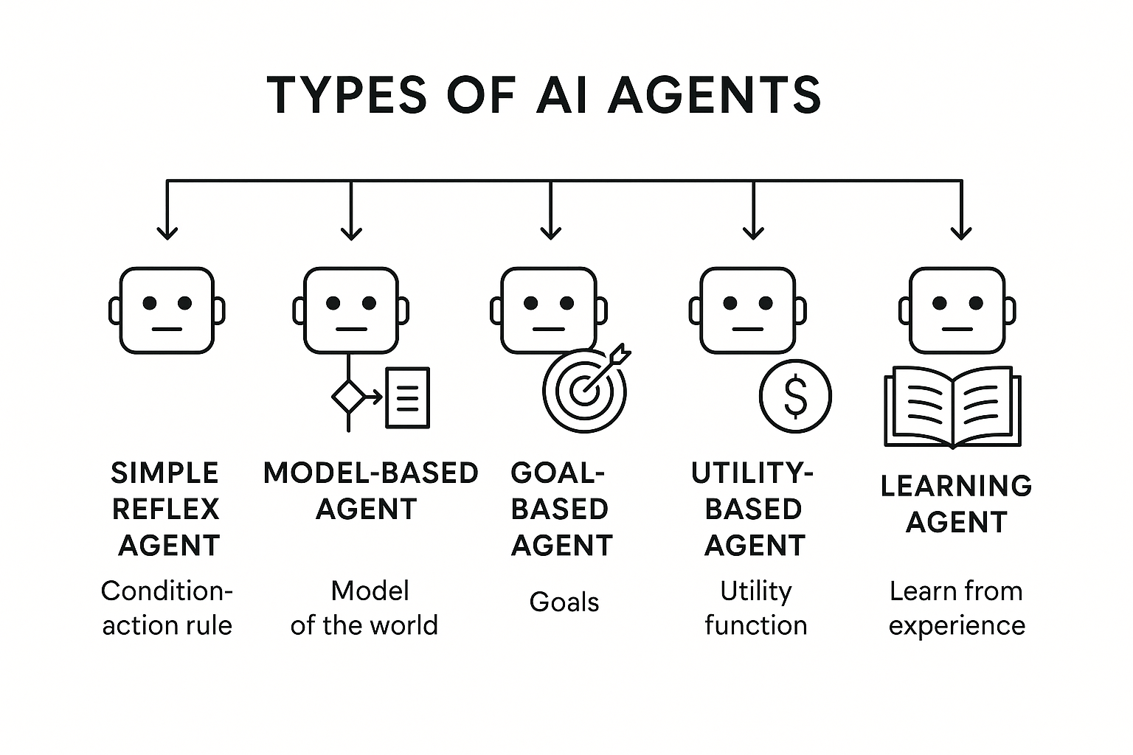

# Q.6 Write down the steps BFS Algorithm and explain it with an example

Breadth-First Search (BFS) Algorithm:  
  
Steps:  
1. Start from the source vertex and mark it as visited  
2. Add the source vertex to a queue  
3. While the queue is not empty:  
 a. Dequeue a vertex from the front of the queue  
 b. Process/visit the vertex  
 c. For each unvisited adjacent vertex:  
 - Mark it as visited  
 - Enqueue it to the rear of the queue  
4. Repeat until queue is empty  
  
Example:  
Consider a graph with vertices A, B, C, D, E, F connected as:  
A connects to B, C  
B connects to A, D, E   
C connects to A, F  
D connects to B  
E connects to B, F  
F connects to C, E  
  
BFS Traversal starting from A:  
1. Start: Queue = [A], Visited = {A}  
2. Dequeue A, visit neighbors B, C: Queue = [B, C], Visited = {A, B, C}  
3. Dequeue B, visit neighbors D, E: Queue = [C, D, E], Visited = {A, B, C, D, E}   
4. Dequeue C, visit neighbor F: Queue = [D, E, F], Visited = {A, B, C, D, E, F}  
5. Dequeue D, E, F (no new neighbors): Queue = [], All vertices visited  
  
Final BFS order: A → B → C → D → E → F  
  
Time Complexity: O(V + E) where V is vertices and E is edges  
Space Complexity: O(V) for queue and visited set

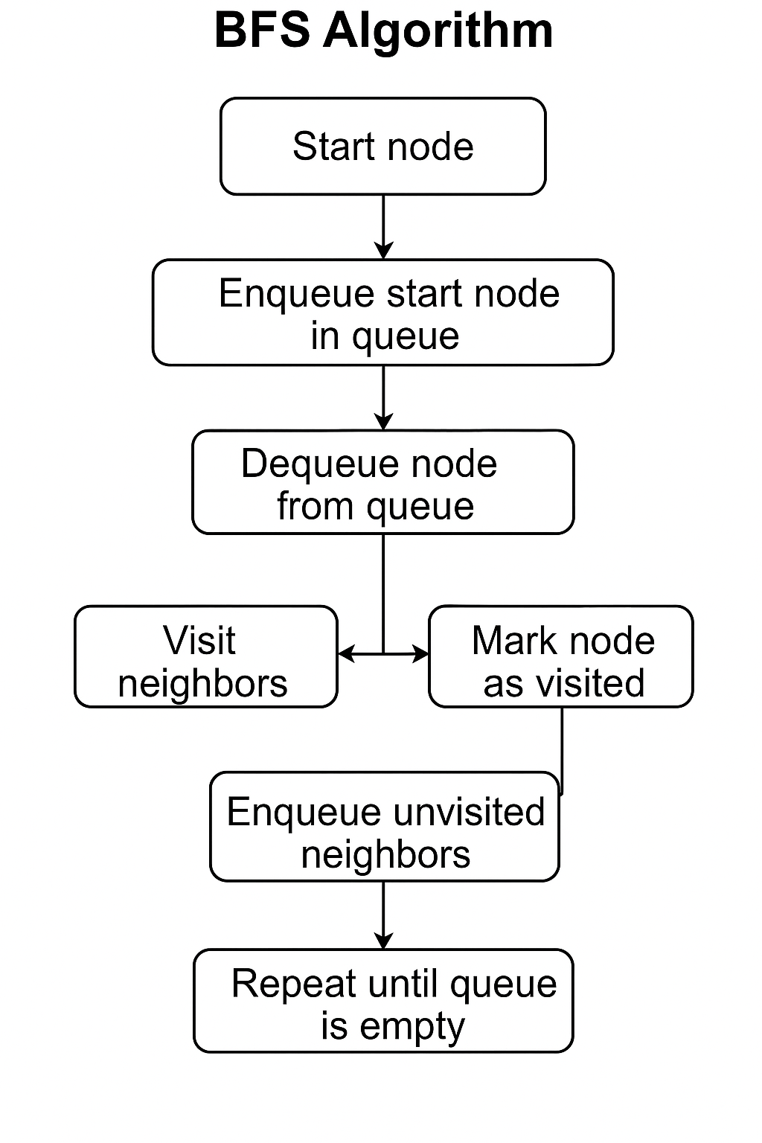

# Q.7 Do the comparison between DFS and BFS

|  |  |  |
| --- | --- | --- |
| **Aspect** | **DFS (Depth-First Search)** | **BFS (Breadth-First Search)** |
| Data Structure Used | Stack (LIFO) | Queue (FIFO) |
| Strategy | Goes deep into one path | Explores level by level |
| Memory Usage | Less memory required | More memory required |
| Time Complexity | O(V + E) | O(V + E) |
| Space Complexity | O(h) where h is max depth | O(w) where w is max width |
| Optimal Solution | Not guaranteed for unweighted | Guaranteed for unweighted |
| Implementation | Recursive or explicit stack | Iterative with queue |
| When to Use | Puzzle solving, cycle detection | Shortest path, level traversal |
| Backtracking | Natural backtracking | No backtracking |
| Complete | Not complete in infinite spaces | Complete if finite branching |

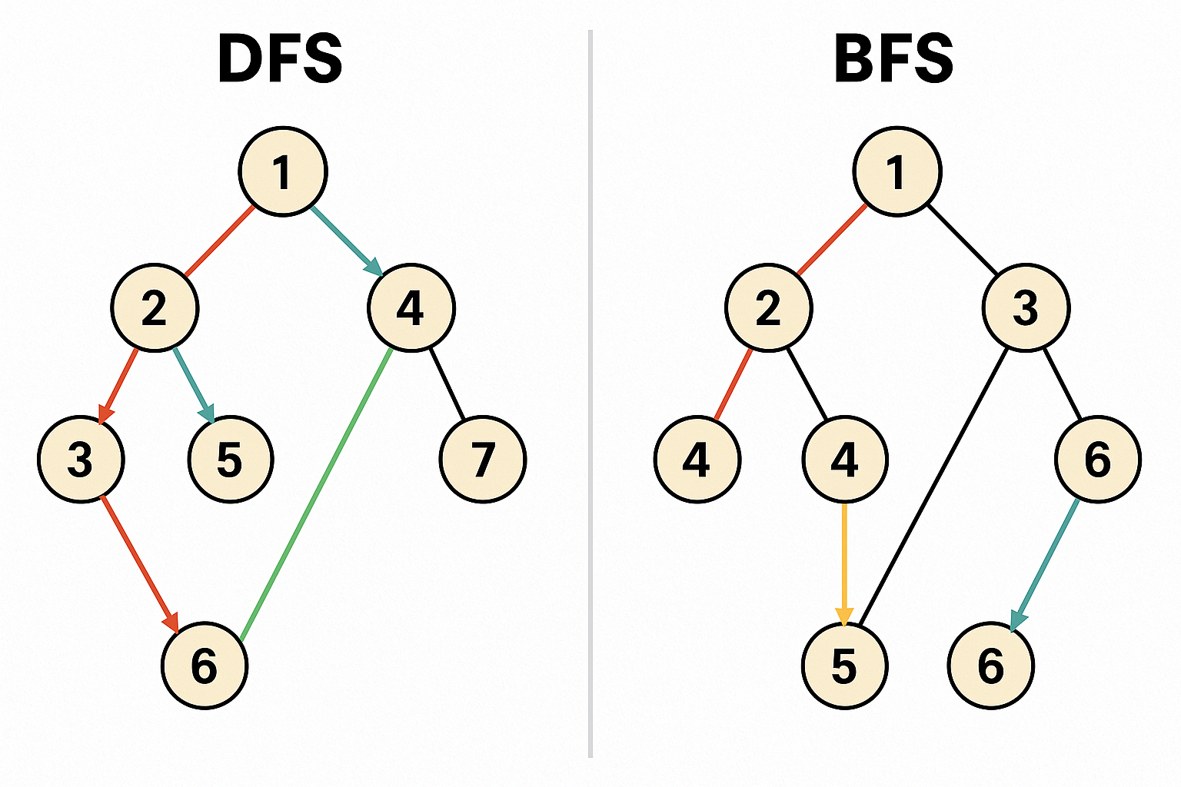

# Q.8 Give an example of a problem for which breadth first search would work better than depth first search

Problem: Finding the Shortest Path in an Unweighted Graph  
  
Example: Social Network "Degrees of Separation"  
Find the shortest connection path between two people in a social network.  
  
Scenario:   
- Person A wants to connect to Person F  
- Each connection represents one degree of separation  
- Goal: Find minimum number of connections needed  
  
Network:  
A connects to B, C  
B connects to D  
C connects to E   
D connects to F  
E connects to F  
  
BFS Solution:  
- Level 0: A  
- Level 1: B, C (1 degree from A)  
- Level 2: D, E (2 degrees from A)   
- Level 3: F (3 degrees from A)  
  
BFS finds shortest path: A → B → D → F (3 connections)  
  
DFS might find: A → C → E → F (also 3 connections) or could explore deeper unnecessary paths first.  
  
Why BFS is better:  
1. Guarantees shortest path in unweighted graphs  
2. Explores all paths of length k before exploring paths of length k+1   
3. Finds optimal solution first  
4. In social networks, closer connections are typically more valuable  
5. BFS naturally implements the concept of "degrees of separation"  
  
Other examples where BFS is preferred:  
- Web crawling (closer pages first)  
- Broadcasting in networks  
- GPS navigation (shortest route)  
- Puzzle solving with minimum moves

# Q.9 Explain Brute Force Search Strategies with an example

Brute Force Search Strategies:  
  
Brute force search is an exhaustive search approach that systematically tries all possible solutions until the correct one is found or all possibilities are exhausted.  
  
Characteristics:  
• Exhaustive: Examines every possible solution  
• Uninformed: No domain knowledge used to guide search   
• Guaranteed: Will find solution if one exists  
• Inefficient: Often has high time complexity  
  
Types of Brute Force Search:  
  
1. Linear Search:  
 • Checks each element sequentially  
 • Time complexity: O(n)  
  
2. Exhaustive Tree Search:  
 • Explores all branches of search tree  
 • Examples: DFS, BFS without heuristics  
  
3. Generate and Test:  
 • Generate all possible candidates  
 • Test each until solution found  
  
Example: 8-Queens Problem  
  
Problem: Place 8 queens on a chessboard so that no two queens attack each other.  
  
Brute Force Approach:  
1. Generate all possible ways to place 8 queens on 64 squares  
2. Total possibilities: C(64,8) = 4,426,165,368 combinations  
3. Test each combination to see if queens attack each other  
4. Return first valid configuration found  
  
Pseudocode:  
```  
for each possible placement of 8 queens:  
 if no two queens attack each other:  
 return this placement  
 else:  
 continue to next placement  
return "No solution found"  
```  
  
Why Brute Force is Inefficient Here:  
• Explores invalid states that could be eliminated early  
• Doesn't use constraint knowledge (queens can't be on same row/column/diagonal)  
• Better approach: Backtracking with constraint checking  
  
When to Use Brute Force:  
• Small problem size  
• No obvious optimization available  
• Need to verify all solutions exist  
• Simple implementation required

# Q.10 How does backtrack work in DFS?

Backtracking in DFS:  
  
Backtracking is a systematic method for exploring solution spaces. In DFS, backtracking occurs when the algorithm reaches a dead end or determines that the current path cannot lead to a solution.  
  
How Backtracking Works in DFS:  
  
1. Forward Movement:  
 • DFS explores as deep as possible along a branch  
 • Moves forward by selecting an unvisited child node  
 • Continues until reaching a leaf or dead end  
  
2. Backtrack Condition:  
 • No more unvisited adjacent nodes  
 • Current path violates constraints  
 • Goal cannot be reached from current state  
  
3. Backtrack Process:  
 • Return to previous node (parent)  
 • Mark current path as explored  
 • Try alternative branches from parent  
 • Continue this process recursively  
  
Example: Maze Solving  
  
```  
DFS_Backtrack(current_position, goal, path):  
 if current_position == goal:  
 return True // Solution found  
  
 mark current_position as visited  
 add current_position to path  
  
 for each adjacent_position:  
 if adjacent_position is valid and not visited:  
 if DFS_Backtrack(adjacent_position, goal, path):  
 return True  
  
 // Backtrack step  
 remove current_position from path   
 mark current_position as unvisited  
 return False  
```  
  
Backtracking Steps:  
1. Try current position  
2. If it leads to solution, keep it  
3. If it leads to dead end, undo the choice (backtrack)  
4. Try next alternative  
5. Repeat until solution found or all options exhausted  
  
Key Features:  
• Systematic exploration of solution space  
• Prunes invalid branches early  
• Undoes choices when they don't work  
• Memory efficient (only stores current path)  
• Natural fit with recursive implementation  
  
Applications:  
• N-Queens problem  
• Sudoku solving   
• Knight's tour  
• Graph coloring  
• Constraint satisfaction problems

# Q.11 Explain and write the Difference between Heuristic and Non-Heuristic Search Algorithm

Heuristic vs Non-Heuristic Search Algorithms:  
  
Non-Heuristic (Blind/Uninformed) Search:  
• No additional information about goal location  
• Searches systematically without guidance  
• Examples: BFS, DFS, Uniform Cost Search  
• Explores search space exhaustively  
• Guaranteed to find solution if exists (complete)  
• Can be very time and space consuming  
  
Heuristic (Informed) Search:  
• Uses domain-specific knowledge (heuristic function)   
• Guides search toward more promising areas  
• Examples: A*, Greedy Best-First, Hill Climbing  
• More efficient path to goal  
• May sacrifice completeness for efficiency  
• Depends on quality of heuristic function

|  |  |  |
| --- | --- | --- |
| **Aspect** | **Non-Heuristic Search** | **Heuristic Search** |
| Information Used | Only search space structure | Additional domain knowledge |
| Search Strategy | Systematic/exhaustive | Guided by heuristic |
| Efficiency | Often inefficient | More efficient |
| Completeness | Usually complete | May not be complete |
| Optimality | May guarantee optimal | Depends on heuristic |
| Memory Usage | Can be high | Usually lower |
| Examples | BFS, DFS, UCS | A*, Greedy, Hill Climbing |
| Implementation | Simpler | More complex |
| Problem Dependency | Domain independent | Requires domain knowledge |

# Q.12 Why does one go for heuristics search?

Reasons to Use Heuristic Search:  
  
1. Efficiency:  
 • Reduces search time significantly  
 • Focuses on promising areas of search space  
 • Avoids exhaustive exploration  
  
2. Resource Optimization:  
 • Lower memory requirements  
 • Reduced computational costs  
 • Faster convergence to solutions  
  
3. Scalability:  
 • Handles large search spaces effectively  
 • Remains practical for complex problems  
 • Better performance as problem size increases  
  
4. Real-world Applicability:  
 • Many problems have domain knowledge available  
 • Human experts can provide guidance  
 • Natural fit for practical applications  
  
5. Intelligent Behavior:  
 • Mimics human problem-solving approach  
 • Uses available information intelligently  
 • Makes informed decisions rather than random exploration  
  
6. Goal-Oriented:  
 • Directed toward specific objectives  
 • Prioritizes paths likely to succeed  
 • Focuses computational effort efficiently  
  
Examples where Heuristic Search is Preferred:  
• Route finding (GPS navigation)  
• Game playing (Chess, Go)  
• Robotics path planning  
• Resource allocation  
• Scheduling problems  
• Puzzle solving  
  
Trade-offs:  
• May miss optimal solution  
• Depends on heuristic quality  
• Requires domain expertise  
• More complex implementation

# Q.13 What are the advantages of heuristic function?

Advantages of Heuristic Functions:  
  
1. Improved Efficiency:  
 • Significantly reduces search time  
 • Guides search toward goal  
 • Eliminates unnecessary exploration  
  
2. Resource Conservation:  
 • Lower memory consumption  
 • Reduced CPU usage  
 • More cost-effective solutions  
  
3. Scalability:  
 • Handles large problem spaces  
 • Maintains performance as complexity increases  
 • Enables solving previously intractable problems  
  
4. Flexibility:  
 • Can be adapted to different domains  
 • Allows incorporation of expert knowledge  
 • Customizable for specific applications  
  
5. Real-time Performance:  
 • Faster response times  
 • Suitable for time-critical applications  
 • Interactive system responsiveness  
  
6. Quality Solutions:  
 • Often finds good solutions quickly  
 • Balances solution quality with efficiency  
 • Practical for many applications  
  
7. Intelligent Decision Making:  
 • Uses available information wisely  
 • Makes informed choices  
 • Mimics human expertise  
  
8. Problem-Specific Optimization:  
 • Tailored to specific problem characteristics  
 • Leverages domain knowledge effectively  
 • Exploits problem structure  
  
Key Properties of Good Heuristics:  
• Admissible: Never overestimate actual cost  
• Consistent: Satisfies triangle inequality  
• Informative: Provides meaningful guidance  
• Efficient: Fast to compute

# Q.14 Explain the Fuzzy Logic Systematic Architecture

Fuzzy Logic System Architecture:  
  
A Fuzzy Logic System (FLS) consists of four main components that work together to process imprecise or uncertain information:  
  
1. Fuzzification Module:  
 • Converts crisp input values to fuzzy sets  
 • Uses membership functions to assign degrees of membership  
 • Maps precise inputs to linguistic variables  
 • Example: Temperature 75°F → "Warm" with degree 0.7  
  
2. Knowledge Base (Rule Base):  
 • Contains fuzzy IF-THEN rules provided by experts  
 • Represents domain knowledge in linguistic form  
 • Example rules:  
 - IF temperature is HOT AND humidity is HIGH THEN cooling is MAXIMUM  
 - IF temperature is COLD THEN heating is HIGH  
  
3. Inference Engine:  
 • Simulates human reasoning process  
 • Applies fuzzy rules to fuzzified inputs  
 • Uses fuzzy reasoning methods (Mamdani, Sugeno)  
 • Combines results from multiple rules  
 • Handles uncertainty and imprecision  
  
4. Defuzzification Module:  
 • Converts fuzzy output to crisp value  
 • Uses various methods:  
 - Center of Gravity (COG)  
 - Mean of Maximum (MOM)  
 - Center of Area (COA)  
 • Produces actionable output for system control  
  
Process Flow:  
1. Crisp inputs → Fuzzification  
2. Fuzzy sets → Rule evaluation (Inference)  
3. Fuzzy conclusions → Rule aggregation   
4. Fuzzy output → Defuzzification  
5. Crisp output → System action  
  
Advantages of Architecture:  
• Handles imprecise information naturally  
• Incorporates expert knowledge easily  
• Provides smooth control behavior  
• Robust to noise and uncertainty  
• Intuitive rule representation  
  
Applications:  
• Temperature control systems  
• Automotive systems (ABS, transmission)  
• Consumer appliances (washing machines)  
• Industrial process control  
• Decision support systems

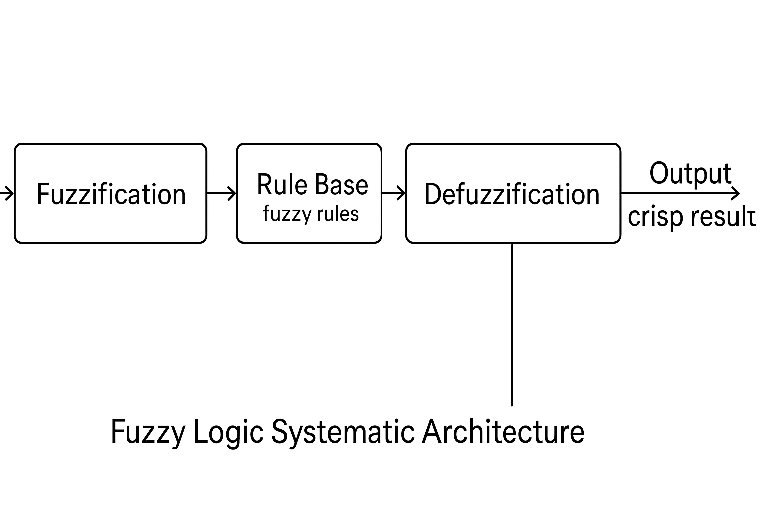

# Q.15 List down the Application Area of Fuzzy Logic

Application Areas of Fuzzy Logic:  
  
1. Consumer Electronics:  
 • Washing machines (load sensing, water level)  
 • Air conditioners (temperature control)  
 • Microwave ovens (cooking time/power)  
 • Vacuum cleaners (suction power)  
 • Digital cameras (focus, exposure)  
 • Refrigerators (temperature control)  
  
2. Automotive Industry:  
 • Anti-lock Braking System (ABS)  
 • Automatic transmission control  
 • Engine control systems  
 • Climate control  
 • Cruise control  
 • Parking assistance systems  
  
3. Industrial Automation:  
 • Process control systems  
 • Quality control  
 • Manufacturing optimization  
 • Robotics control  
 • Supply chain management  
 • Equipment monitoring  
  
4. Healthcare and Medical:  
 • Medical diagnosis systems  
 • Drug dosage control  
 • Patient monitoring  
 • Medical image analysis  
 • Anesthesia control  
 • Prosthetic control  
  
5. Finance and Business:  
 • Credit risk assessment  
 • Investment decision making  
 • Portfolio management  
 • Market analysis  
 • Bankruptcy prediction  
 • Customer behavior analysis  
  
6. Transportation:  
 • Traffic light control  
 • Route optimization  
 • Fleet management  
 • Railway systems  
 • Airport operations  
 • Traffic flow management  
  
7. Information Technology:  
 • Pattern recognition  
 • Image processing  
 • Data mining  
 • Information retrieval  
 • Network security  
 • Database querying  
  
8. Aerospace and Defense:  
 • Flight control systems  
 • Missile guidance  
 • Target recognition  
 • Navigation systems  
 • Satellite control  
 • Radar systems  
  
9. Environmental Systems:  
 • Weather prediction  
 • Water treatment  
 • Air pollution control  
 • Environmental monitoring  
 • Waste management  
 • Energy management  
  
10. Education and Psychology:  
 • Student performance evaluation  
 • Learning systems  
 • Psychological diagnosis  
 • Educational assessment  
 • Adaptive learning platforms  
 • Behavioral analysis  
  
11. Entertainment and Gaming:  
 • Game AI behavior  
 • Character control  
 • Dynamic difficulty adjustment  
 • Virtual reality systems  
 • Animation control  
 • Interactive entertainment  
  
12. Agriculture:  
 • Irrigation control  
 • Crop monitoring  
 • Pest control  
 • Yield prediction  
 • Soil analysis  
 • Weather-based farming